Year 13 Pastoral Curriculum

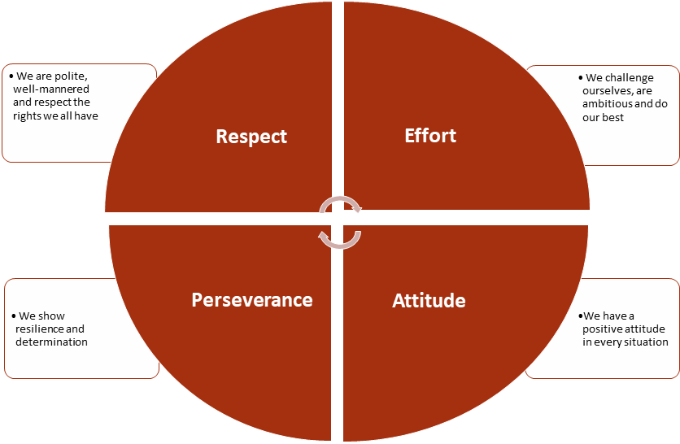

 | Week A AM (30 mins) | 1:1s | Week B AM (30 mins) | 1:1s
Monday | Personal Development/Progression – Unifrog, MOOCS etc. | N/A | Assembly (LAN) - The Well | 8.50-9.15am
Tuesday | Personal Development/Progression – Unifrog, MOOCS etc. | N/A | PSRE session (TBC) – the Well | 8.50-9.15am
Wednesday | Assembly (LAN) - The Well | 8.50-9.15am | Personal Development/ Progression – Unifrog, MOOCS etc. | N/A
Thursday | Quiz (Tutor rooms) | N/A | Quiz (The Well) | 8.50-9.15am
Friday | Admin, Week Ahead, News (+Flexible) | 9am-9.15am | Admin, Week Ahead, News (+Flexible) | 9am-9.15am
* Y13 mentoring should involve 120 mins of mentoring per cycle (6 sessions ). These should be determined by the tutor and communicated to REN & LAN. Notes to be recorded in Unifrog.
Weekly assemblies – celebrating success, sharing key reminders
Overview of Y13 Tutorial Programme
Term | Primary focus for Year 13
Autumn term first half | - Target setting for Y13 (Review Y12) – move partly to end of Y12?  - Progression (2 PD sessions per cycle);  - UCAS applications (2-3 sessions)  - Personal statement – 5 discrete sessions in “toolkit”  - Progression focus for those not taking university route. Research opportunities  - Seek experiences to bolster application.  - Super curricular (1 session per cycle)  - Mental health & wellbeing  - PSRE (TBC)
Autumn term second half | - Progression (2 PD sessions per cycle);  - UCAS applications (2-3 sessions)  - Progression focus for those not taking university route. Research opportunities  - Super curricular (1 session per cycle)  - Seek experiences to bolster application.  - Preparation for interviews and creation of portfolios  - Identify weak areas regarding interviewing and get help to improve  - Preparation for January PPES - Critical Thinking around effective revision techniques* PLUS sessions to apply techniques TBC.
Spring term first half | - Revision skills  - Identify weak areas in subject knowledge and investigate ways to improve them  - Promote teacher discussion (RSL meetings and faculty time)  - Mental health & wellbeing
Spring term second half | - PPE  - Acting on feedback from PPE  - Target setting (post PPEs)  - Prep for Post Y13  - Finance  - Independence  - Coping with life away from home – Freshers’ Week etc.
Summer term first half | - Next steps for those that are not taking university route.  - Revision and target setting
Summer term second half | N/A

Key
PSRE
British Values
Gatsby benchmarks/Progression

Tutor Periods 2025/26
Date | Year 13
Monday 8th September ’25 – Period 1 | Assembly – Making a new ending : the year ahead
Thursday 25th September ’25 – Period 2 | Progression – UCAS, Apprenticeships etc.
Tuesday 18th November ’25- Period 3 | Financial health and wellbeing – Financial independence post-TBS (LAN launching Sixth Form to Y11)
Thursday 18th December ’25 – Period 5 | Christmas Quiz
Thursday 8th January ’26 – Period 2 | Mental Health (MHST)
Thursday 26th March ’24 – Period 1/Period 2 | Year group photo
Thursday 17th June ’24 – Period 2 | STUDY LEAVE
Wednesday 7th July ’24 – Period 2 | STUDY LEAVE
Friday 23rd July ’22 – Period ‘24 | STUDY LEAVE

Tutorial Programme – week by week
 | Week |  | Resources
 | 1 | Transition Y12 to Y13  - Complete Tutor Review 1  - Target setting (plugging “gaps”) | https://www.netsixthform.co.uk/resources/view/the-leap-from-year12-to-year-13  https://www.netsixthform.co.uk/resources/view/turning-it-around-in-year-13-video  Booklet pages 3-6
 | 2 | Progress with “Next Steps”  - Complete Tutor Review 2 | Booklet pages 7-9  https://www.netsixthform.co.uk/resources/view/next-steps-1-considering-an-apprenticeship
 | 3 | - The importance of supercurricular learning  - What is “Plan B”? – non-UCAS pathways | https://www.netsixthform.co.uk/resources/view/not-going-to-university-brief-guide  A Level Mindset  Netsixthform
 | 4 | Supercurricular – MOOCs  Linking Supercurricular to the Personal Statement | https://www.netsixthform.co.uk/resources/view/personal-statements-preparation-through-academic-experiences-video
 | 5 | Mental Health (WMHD) | https://www.netsixthform.co.uk/resources/view/mental-health-feeling-overwhelmed-video
 | 6 | Organisation –Why sleep is essential | A Level Mindset  Netsixthform  https://www.netsixthform.co.uk/resources/view/sleep-is-essential  https://www.netsixthform.co.uk/resources/view/sleep-and-learning-powerpoint
 | 7 | Launch PPE preparation – Making a plan for January | LAN & WMS resources on effective revision – plan, practice, review etc.
8 |  | British Values – Democracy : How are laws made? | https://learning.parliament.uk/en/resources/how-laws-are-made/
9 |  | Motivation/Study Skills/PiXL Stretch/ Interleaving | A Level Mindset  Netsixthform
10 |  | Progression : Formal communication
11 |  | Year 13 Tutor Review 4 : Autumn academic review | Booklet, P.10
12 |  | Motivation/Attitude/Study Skills/PiXL Stretch 35. Kill your Critic
13 |  | Reflection on Term 1 | Booklet pages 11-13
14 |  | PPE preparation | Booklet pages 15-17
15 |  | Progression : Interview technique
CHRISTMAS HOLIDAY
16 |  | Exam preparation : environment | HAR resources
17 |  | Exam preparation : in the exam room | HAR resources
18 |  | CV writing/ PiXL Stretch | https://www.netsixthform.co.uk/resources/view/writing-your-c-v-what-to-include
19 |  | Aiming to the Top | NetSixthForm
20 |  | British Values – Individual Liberty
21 |  | CV writing/ PiXL Stretch | https://www.netsixthform.co.uk/resources/view/writing-your-c-v-what-to-include
22 |  | Applying for Student Finance | (Pete Harrison - TBC)
23 |  | Keeping a balance – Managing stress and anxiety in the exam season | https://www.netsixthform.co.uk/resources/browse?category[]=115&free=
24 |  | Target Setting Post PPE /Horsforth Quadrant | PiXL
25 |  | Final Academic Review/ Job application | Tutor Review 9
26 |  | Revision and Target Setting/ Job application/ | NetSixthForm (TBC)
EASTER HOLIDAY
27 |  | Revision and Target Setting/ Job application/ | https://pixl.huddle.net/workspace/21044136/files/#/76260778 PiXL Revisit
28 |  | British values : democracy and local government | LAN resource
29 |  | Next Steps/Revision/Job application
30 |  | Flexible

