Subject: Drama
Subject Leader: Ms Anna Clements
Contact email: AClements@blandfordschool.org.uk
Subject statement:
Through Drama, students develop a sense of identity and community through collaborative working. Students are challenged in a variety of ways to reflect on their ability communicate effectively with others, developing skills in understanding themselves and the diverse range of people they will encounter throughout their lives. From creative problem solving to critical analysis, Drama spans the skills students need to contribute positively to their community in future.

Lower Years
How we assess your child’s progress in the lower years:
Students are assessed against criteria derived from the GCSE specification to show a clear journey of progress from year 7 through to year 11. Assessments happen during rehearsal, performance and evaluation stages of each project.
There are four areas of criteria that need to be fulfilled throughout Key Stage 3 that are defined by Edexcel GCSE requirements:
- AO1 Create and develop ideas to communicate meaning for theatrical performance
- AO2 Apply theatrical skills to realise artistic intentions in live performance
- AO3 Demonstrate knowledge and understanding of how drama and theatre is developed and performed
- AO4 Analyse and evaluate their own work and the work of others

The following topics are covered in each year:
Year 7:
- Spy School – core skills for Drama through the mystery crime genre. (devising)
- Silent Movies – developing control in physical communication. (devising)
- Musical Theatre – exploring vocal and physical expression through a key performance genre. (scripted)

Year 8:
- Speak up! - public speaking and storytelling to support personal communication skills. (devising)
- Clowning – developing physical control and audience relationship (devising)
- Midsummer Night’s Dream – introduction to Shakespeare in performance. (scripted)

Year 9:
- DNA by Dennis Kelly – introduction to set text and characterisation. (scripted)
- Theatre In Education – creative exploration of current social issues (devising)
- Blood Brothers by Willie Russell – Deeper exploration of characterisation and stage space. (scripted)

Lower Years Curriculum Overview
Year | Autumn Term |  | Spring Term |  | Summer Term
 | Unit / Topic Covered | Intended Outcomes (Knowledge and Skills) | Unit / Topic Covered | Intended Outcomes (Knowledge and Skills) | Unit / Topic Covered | Intended Outcomes (Knowledge and Skills) | Useful resources / websites parents can access to support learning and progress.
7 | Spy School   Devising drama using conventions. Intro to Drama skills and crime mystery genre.  Careers – key life skills referenced throughout Y7. Communication,  co-operation,  confidence,  concentration  CROSS CURRICULAR with DANCE | Tableau and CASTLE acronym  Physical and vocal expression  Basic group working skills – turn taking, listening, compromising  Mime  Slow Motion  Chorus movement  Cross cutting  Thought Tracking  Stage combat | Silent Movies  SILENT MOVIES  CROSS CURRICULAR with DANCE | Physicalising storytelling  Mime  Core genre of creative expression.  Basic group working skills developed through teamwork roles and performance skills | 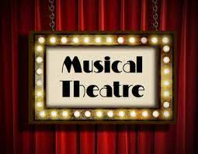  MUSICAL THEATRE  CROSS CURRICULAR with DANCE | Knowledge of a key genre in performance.  Combining physical and vocal skills to create character  Audience awareness  Communication to audience and group members
8 |   SPEAK UP!  Expressive voice work for storytelling and speeches. Careers – public speaking, NVC and self presentation  CROSS CURRICULAR with DANCE and ENGLISH (Oracy) | Folktales from around the world.  Reimagining stories for stage  Vocal expression  Use of gesture and physicality  speaking alone and respecting my voice. | 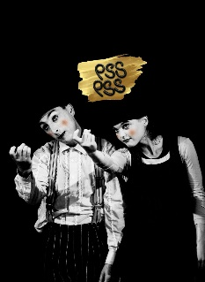  Clowning  CROSS CURRICULAR with DANCE | Mime  Jacques LeCoq technique  Comedic timing  Mirroring  Suspending disbelief ‘the magic of theatre’ | 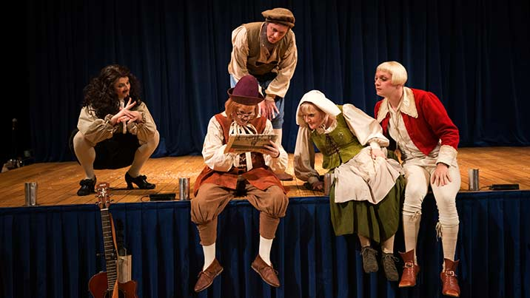  A Midsummer Night’s Dream  Cross-curricular – literacy based work and contextual understanding of British historical period. | Elizabethan England  Thrust staging  The Globe theatre  Historic literature.  Shakespearean language
9 | 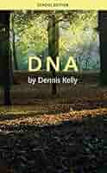  Performance from Text – DNA  SMSC – Themes of DNA include bullying, gangs, peer pressure and responsibility | Introduction to GCSE Set Text  Context  Physical Skills  Vocal Skills  Characterisation  Hot-Seating |   T.I.E  SMSC – Exploring social issues relating to peers and using research to evidence performance content and presenting solutions to community problems. | Augusto Boal – Forum theatre  Stimuli  Thought Tracking  Slow Motion  Narration  Cross-cutting  Physical Theatre  Target Audience | 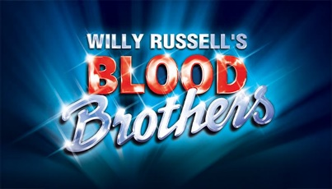Blood Brothers  SMCS – themes of blood brothers include inequality, social class, nature vs nurture, superstition, actions and consequences | Working from script  Levels, proxemics and staging choices.  Power transference  Characterisation  Marking the Moment.

Key Stage 4
Exam board: Edexcel (http://qualifications.pearson.com/en/qualifications/edexcel-gcses/drama-2016.html)
How we assess your child’s progress in Key Stage 4:
Students are assessed throughout the various projects in the GCSE programme.
Component 1 – 40% - Devising performance and portfolio – internally marked and externally moderated.
Component 2 – 20% - Scripted performance – externally marked
Component 3 – 40% - Written Exam on DNA(set text) and Live Theatre Evaluation - externally marked.

The following topics are covered in each year:
Year 10:
- Genres – core genres in the theatrical world from Greek Theatre to contemporary physical theatre (devising)
- Asylum – building character backstory, developing monologues and creatively exploring abstract chorus movement. (devising)
- DNA – further set text study (scripted)
- Production Elements – Technical knowledge of production, appraisal of professional design and realising design ideas.
- Devising Component 1 – exploring stimulus and forming structure and style.
- Devising Component 1 – developing ideas and building dramatic work/ preparing for PPE on DNA.

Year 11:
- Devising Component 1 – preparation and performance of Devised work and completion of process portfolio.
- Script Component 2 – Preparing scripted performance for exam.
- Live Theatre Evaluation and DNA revision in preparation for final written paper in May.

Key Stage Four Curriculum Overview
Year | Autumn Term |  |  |  | Spring Term |  |  |  |  | Summer Term
 | Unit / Topic Covered |  | Intended Outcomes (Knowledge and Skills) |  | Unit / Topic Covered |  | Intended Outcomes (Knowledge and Skills) |  |  | Unit / Topic Covered |  | Intended Outcomes (Knowledge and Skills) | Useful resources / websites parents can access to support learning and progress.
10 | Devising –  ‘Asylum’  Practitioner study  Artaud  Stanislavski  Brecht  Berkoff  Kneehigh | Acting masterclass-  Improvisation  Convincing expression  Justifying the choice  Evaluating impact  Conjuring emotion  Script writing |  | Devising from stimulus  C1 mini project –  Developing performance material from a stimulus considering conventions, style and form.  SMSC – Devising gives students the ability to be reflective about their own beliefs and perspective on life (linked to stimulus), develop knowledge of, and respect for, different people’s faiths, feelings and values, have a sense of enjoyment and fascination in learning about themselves, others and the world around them, use imagination and creativity in their learning, constantly reflect on their experiences. |  | Theatre Production  16 lesson project learning about design elements – lighting, sound, set, costume  Each unit will cover:  The language  Appraisal of professional design  Application of knowledge |  | DNA  C3 – set text study  Script analysis  Directing skills  Design | C1 – Devising process begins  SMSC – Devising gives students the ability to be reflective about their own beliefs and perspective on life (linked to stimulus), develop knowledge of, and respect for, different people’s faiths, feelings and values, have a sense of enjoyment and fascination in learning about themselves, others and the world around them, use imagination and creativity in their learning, constantly reflect on their experiences. |  | https://qualifications.pearson.com/en/qualifications/edexcel-gcses/drama-2016.html  https://www.bbc.co.uk/bitesize/subjects/zbckjxs  DNA by Dennis Kelly
11 | C1 - Devising Exam  Careers – Public performance to live audience.  C2 – Groups and scripts allocated | C1 performances approx. Oct half term  C1 portfolio by Dec deadline  C2 - Rehearsal of key extracts |  | C2 – Final Examination  Careers – Public performance to live audience.  C3 – Revision – Section A  C3 – Section B – see final live theatre performance |  | Visiting Examiner Feb/Mar  DNA revision  Vocab  Structure  Exemplars  Practice Questions  Live Theatre revision  Vocab  Structure  Exemplars  Practice Questions |  | C3 – Revision Section A and B

